**MONISHA.DUSANAPUDI**

**Phase 2 Report: Org Setup & Configuration**

**Non-Profit Donation & Volunteer Management**

**Objective:** The goal of Phase 2 was to provision a Salesforce organization and establish the complete foundational configuration. This includes setting company-wide standards, building a multi-layered security model, and preparing the environment for custom development.

**Dev Org Setup & Salesforce Editions:**

* A new, permanent **Salesforce Developer Edition** organization was created and provisioned

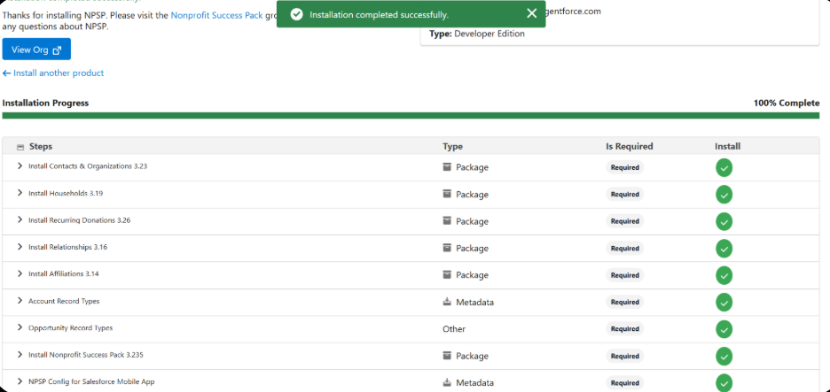

**Company Profile Setup:**

* Navigated to Setup > Company Information and configured the core company profile. The default timezone was set to (GMT+05:30) India Standard Time (Asia/Kolkata) and the currency locale was set to English (India) - INR.

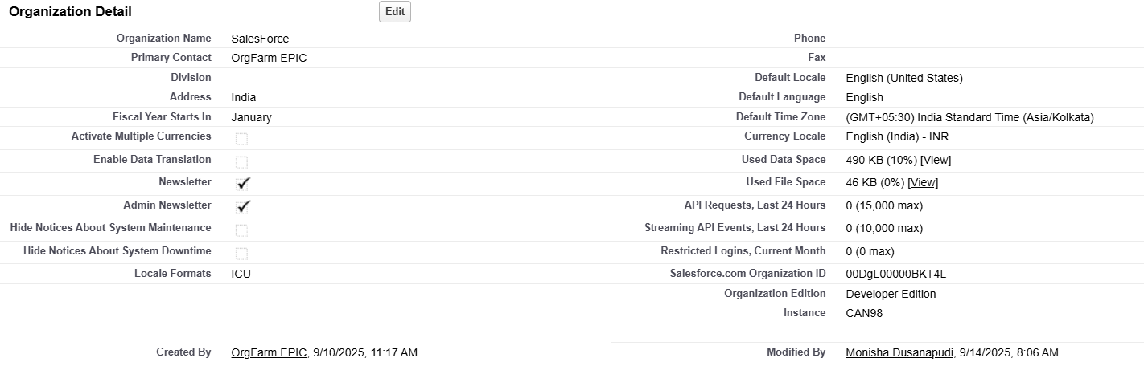

**Business Hours, Holidays & Fiscal Year Settings**

* + **Fiscal Year:** The standard fiscal year setting (January - December) was reviewed and deemed appropriate for the initial needs of the non-profit model.
  + **Business Hours & Holidays:** The setup for specific business hours and holidays was noted but deferred.

**User Setup, Licenses, Profiles & Roles**

* **Action Taken:** A comprehensive user and security hierarchy was established.
  + **Roles:** A three-tier Role Hierarchy was created: CEO > Director of Operations > Volunteer Coordinator. This establishes a data visibility structure based on an organizational chart.

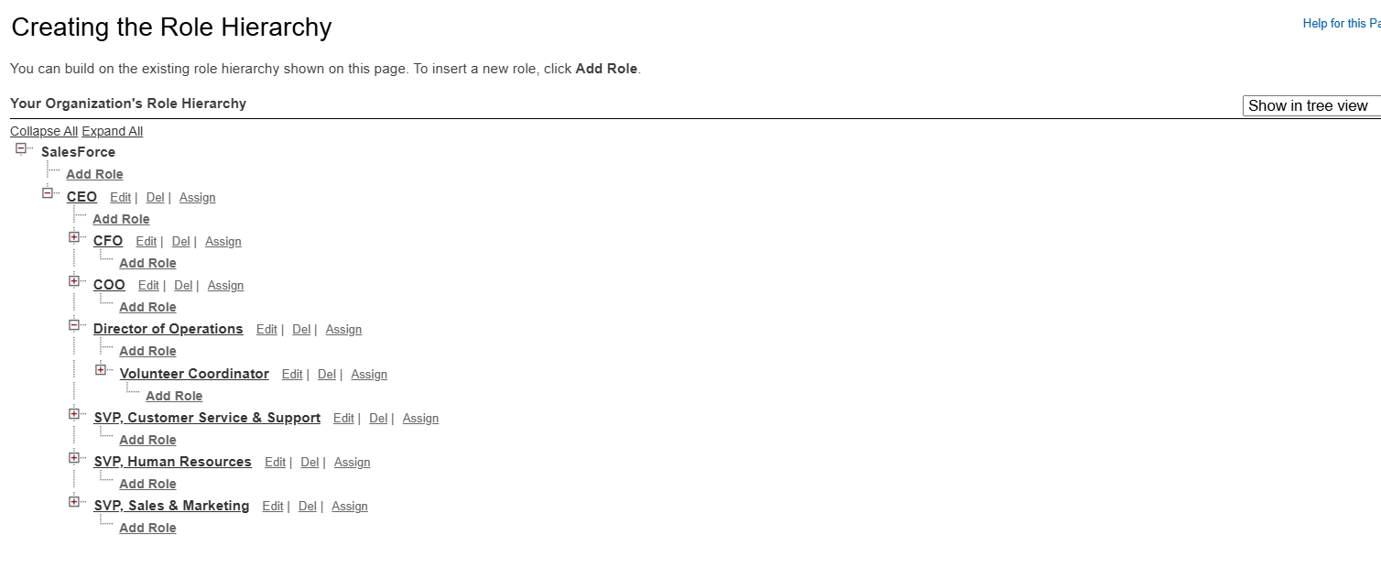

* + **User Setup & Licenses:** A test user, "Valerie Coordinator," was created using a Salesforce license.
  + **Profiles:** The user was assigned the Standard User Profile.

**OWD (Org-Wide Defaults) & Sharing Rules**

* + **OWD:** The Org-Wide Defaults were set to **Private** for the Account, Contact, and Opportunity objects.
  + **Sharing Rules:** The concept of sharing rules as exceptions to OWD was reviewed, but no rules were created in this initial phase.

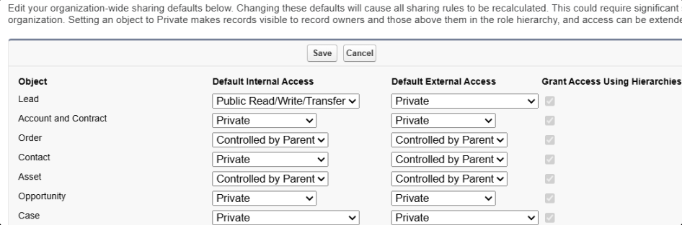

**Login Access Policies**

* **Action Taken:** The policy allowing **"Administrators Can Log in as Any User"** was enabled.

**Sandbox Usage & Deployment Basics**

* For this project, all development and configuration are being performed directly within the Developer Edition org.

**TESTING THIS PHASE**

**Verification & Testing:**

To validate the successful implementation of the security model, a verification test was performed:

1. As the System Administrator, a new Contact record ("John Donor") was created.
2. Using the "Login As" feature, a session was initiated as the lower-level user, "Valerie Coordinator."
3. An attempt was made to view the "All Contacts" list.

**Test Result:** The "John Donor" record was **not visible** to Valerie Coordinator. This result successfully confirms that the Private Org-Wide Default setting is working as designed, preventing a user from accessing records they do not own.

